1.set partitioning to true

set hive.exec.dynamic.partition=true;

set hive.exec.dynamic.partition.mode=nonstrict;

2.create normal table

create table orders_no_partition1(

id string,

customer_id string,

product_id string,

quantity int,

amount double,

zipcode char(5),

country char(2),

state char(2)

)

row format delimited fields terminated by ',';

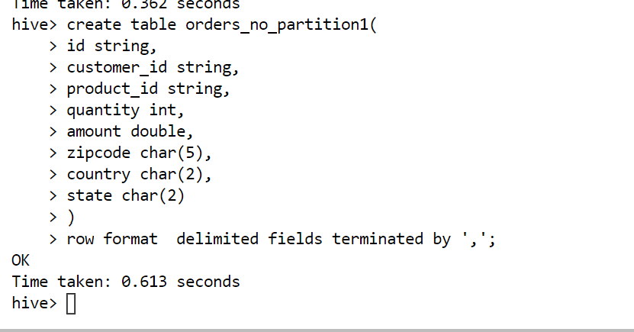

Step3 :inserting data INTO normal table

load data local inpath 'orders_country_w_states.csv' into table orders_no_partition1;



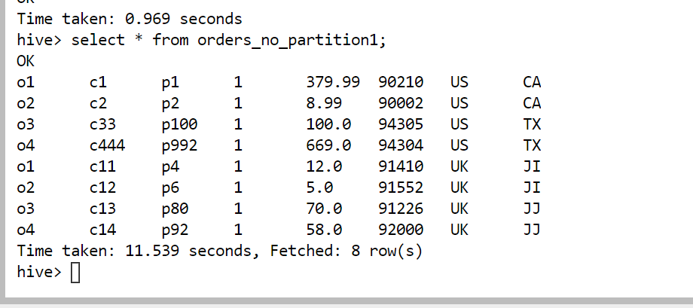

Step 4.create partition table

create table all_orders(

id string,

customer_id string,

product_id string,

quantity int,

amount double,

postalcode string)

partitioned by (country string,state string)

row format delimited fields terminated by ',';

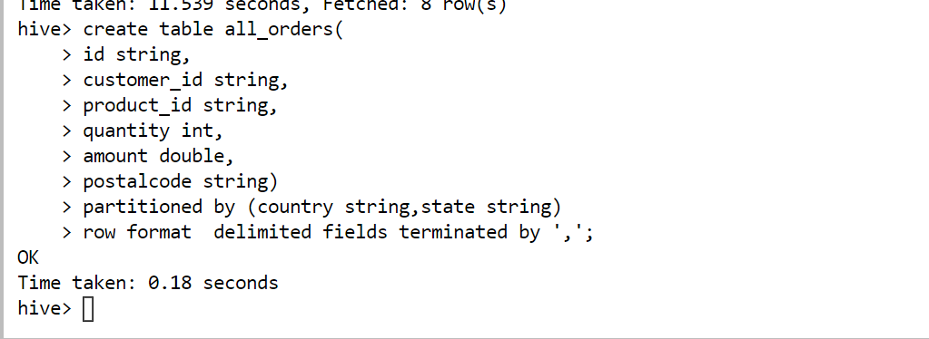

Step 5.insert into partition table

insert into table all_orders

partition(country,state)

select * from orders_no_partition1;

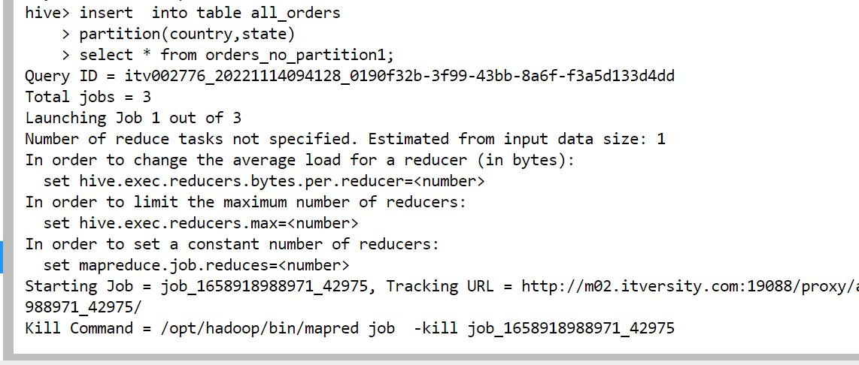

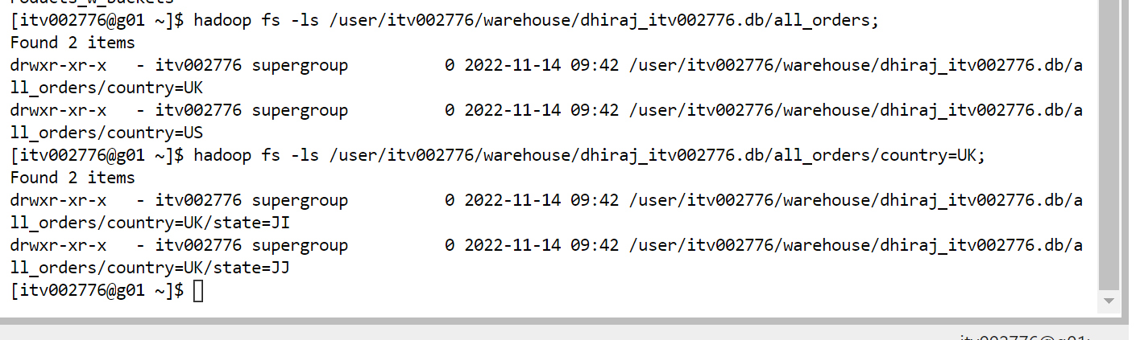

Step 6.show partitions all_orders;

